**Import vs include:**



* Before ansible 2.4, only “include” was available and it behaved differently.

**Importing playbooks:**

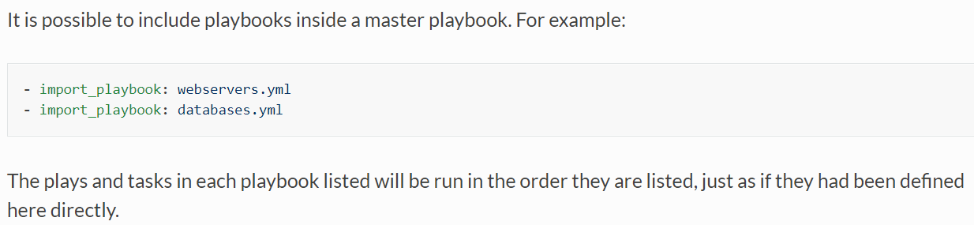

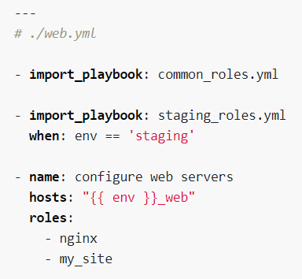

**Including or importing tasks:**

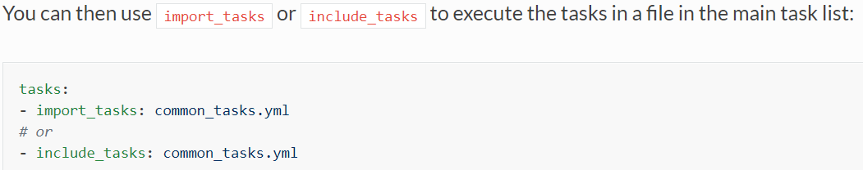

* Once we import the playbooks, we can add the tasks as above.

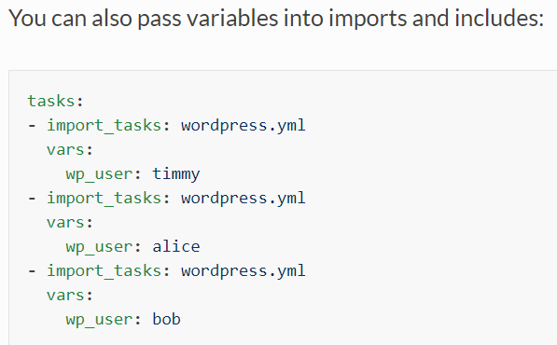

* We can also pass variables into the imported tasks as above.

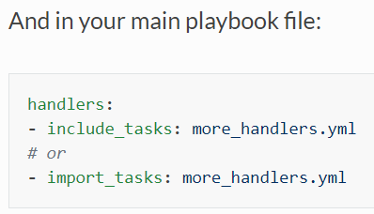

* We can also include the tasks in handlers as above.